

**Final Project Report Template**

1. Introduction
   1. **Project overviews**

This project aims to analyze electric vehicle (EV) charging patterns, range efficiency, and energy consumption using Tableau. The objective is to provide insights into charging behavior, efficiency trends, and potential improvements for EV users and stakeholders.

* 1. **Objectives**
* Analyze EV charging sessions, including duration, energy consumed, and charging frequency.
* Assess battery performance and efficiency based on factors like temperature, driving conditions, and charging habits.
* Identify range variations and their correlation with charging infrastructure, driving speed, and terrain.
* Provide data-driven recommendations for optimizing charging strategies and improving EV range.

1. **Project Initialization and Planning Phase**
   1. **Define Problem Statement**

|  |  |  |  |  |  |
| --- | --- | --- | --- | --- | --- |
| **Bra** | **I am**  **(Customer)** | **I’m trying to** | **But** | **Because** | **Which makes me feel** |
| PS-1 | An EV owner who frequently drives long distances | Find a rerliable and fast charging station during my trips | Charging stations are unavailable or too far apart | There is no real-time availability tracking,and charging networks are not well integrated | Frausted , anxious about Range , and hesitant to take long trips in EV. |
| PS -2 | A fleet manager overseeing multiple electric vehicles for commercial operations. | ensure efficient route planning and minimize downtime due to charging. | charging stations are often occupied, and charging times vary unpredictably. | there is no integrated system to monitor real-time station availability and optimize charging schedules. | frustrated, as delays increase operational costs and reduce overall fleet efficiency. |

**Example:**

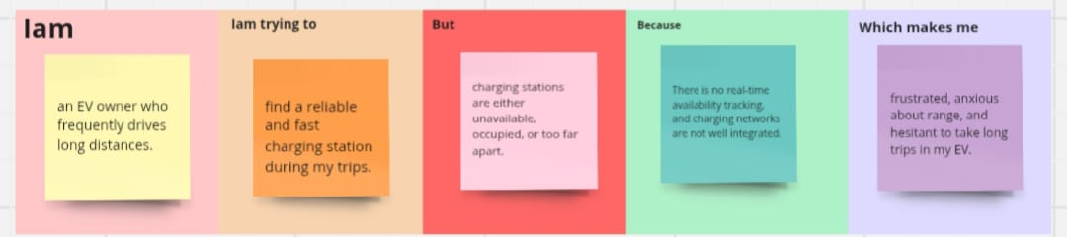

**2.2Proposal (Proposed Solution)**

| **Sprint** | **Functional Requirement (Epic)** | **User Story Number** | **User Story / Task** | **Story Points** | **Priority** | **Team Members** | **Sprint Start Date** | **Sprint End Date (Planned)** |
| --- | --- | --- | --- | --- | --- | --- | --- | --- |
| Sprint-1 | Data collection | VTFEVCRA-1 | Downloading the datasets | 2 | High | Chakali Latha | 16-3-2025 | 16-3-2025 |
| Sprint-2 | Working with dataset | VTFEVCRA-3 | Explaination video links | 1 | High | Mulla Misba Tabasum | 16-3-2025 | 17-3-2025 |
| Sprint-3 | Data visualisation | VTFEVCRA-7 | visualisations | 2 | high | Mulla Misba Tabasum | 17-3-2025 | 18-3-2025 |
| Sprint-4 | Dashboard | VTFEVCRA-19 | Responsive and design of dashboard | 2 | medium | Mulla Misba Tabasum | 18-3-2025 | 18-3-2024 |
| Sprint-4 | Creating the Dashboard | VTFEVCRA-20 | Dashboard Publishing | 2 | medium | Chakali Latha | 18-3-2025 | 18-3-2025 |
| Sprint-5 | Story | VTFEVCRA-21 | No. of scenes of story | 2 | High | Mulla Misba Tabasum | 19-3-2025 | 19-3-2025 |
| Sprint-5 | Creating the Story Board | VTFEVCRA-22 | Number of visualisations/graphs | 2 | medium | Chakali Latha | 19-3-2025 | 20-3-2025 |
| Sprint -7 | Performance testing | VTFEVCRA-26 | Utilisation of filters | 1 | high | Mulla Misba Tabasum | 20-3-2025 | 20-3-2025 |
| Sprint-6 | Web integration | VTFEVCRA-24 | Go to dashboard/story,click on share button on the top ribbon | 2 | high | Chakali Latha | 20-3-2025 | 21-3-2025 |
| Sprint-6 | Web integration | VTFEVCRA-25 | Dashboard and story embed with UI with flask | 2 | high | Chakali Latha | 22-3-2025 | 22-3-2025 |

**Initial Project Planning**

| **Project Overview** | | | | |
| --- | --- | --- | --- | --- |
| Objective | The primary objective of this project is to analyze and visualize electric vehicle (EV) charging patterns, battery efficiency, and driving range using Tableau. The goal is to provide a detailed overview of charging behavior, energy consumption, and range variations under different conditions. The insights will help EV users, fleet operators, and policymakers optimize charging strategies and improve overall EV efficiency. | | | |
| Scope | The scope of this project includes:   * Collection and analysis of EV charging data, battery performance, and driving range metrics. * Creating interactive and insightful visualizations using Tableau to highlight trends in charging habits, efficiency, and energy consumption. * Developing a user-friendly dashboard to help stakeholders explore key factors affecting EV performance and range. * Identifying correlations between charging patterns, environmental conditions, and range efficiency to provide actionable recommendations. | | | |
| **Problem Statement** | | | | |
| Description | Electric vehicles (EVs) generate vast amounts of data on charging patterns, battery efficiency, and range. However, analyzing this data to optimize charging strategies and improve range efficiency is challenging. This project uses Tableau to create interactive visualizations, making EV charge and range insights more accessible for users, fleet managers, and policymakers. | | | |
| Impact | * By solving this problem, the project will make data about electric vehicle (EV) charging and range analysis easily accessible, helping: * EV Owners & Drivers: Optimize trip planning by understanding charging station locations, range limitations, and charging efficiency. * City Planners & Policymakers: Identify trends in EV usage to improve charging infrastructure and support sustainable urban mobility. * Environmental Analysts: Assess the impact of EV adoption on carbon emissions and energy consumption.. | | | |
| **Proposed Solution** | | | | |
| Approach | The methodology for this project involves the following key steps:   1. **Data Collection**: Collect data on UNESCO World Heritage Sites, including location, cultural significance, visitor numbers, and status of preservation. 2. **Data Preparation**: Clean and preprocess the collected data to ensure its accuracy and compatibility for analysis in Tableau. 3. **Visualization Development**: Use Tableau to create interactive dashboards and visualizations that present the data in a user-friendly and engaging manner. 4. **User Testing**: Conduct user testing to gather feedback and refine the visualizations for ease of use and effectiveness. 5. **Deployment**: Publish the final interactive dashboard for public access. | | | |
| Key Features | * **Geographical Mapping**: Interactive maps to visualize the global distribution of UNESCO World Heritage Sites. * **Historical Trends**: Visualizations that track the number of heritage sites added over time. * **Visitor Statistics**: Insights into annual visitors and how they impact the preservation and popularity of sites. * **Search and Filter Options**: Ability to filter by site type (cultural, natural, mixed), geographical region, or year of inscription. * **Preservation Status**: Status indicators showing whether a site is endangered or well-preserved. | | | |
| **Resource Type** | | | **Description** | **Specification/Allocation** |
| **Hardware** | | | | |
| Computing Resources | | | High-performance system for data processing and visualization development | Example: Intel Core i7 or higher processor, 4 cores, 3.0 GHz or faster |
| Memory | | | Sufficient RAM for smooth operation of Tableau and data processing | Example: 16 GB RAM |
| Storage | | | Adequate disk space to store large datasets and Tableau files | Example: 500 GB SSD |
| **Software** | | | | |
| Frameworks | | | Tableau for visualization and analysis | Example: Tableau Desktop or Tableau Public for creating visualizations |
| Libraries | | | Python for data cleaning and preprocessing (if needed) | Example: pandas, numpy, matplotlib for data preparation |
| Development Environment | | | Integrated development environment (IDE) for Python scripting and version control for code collaboration | Example: Jupyter Notebook, Git, GitHub |
| **Data** | | | | |
| Data | | | **Data Source**: Government EV infrastructure database | * Example: CSV or Excel format * Size: ~500-1000 records (depending on the data included) * Format: CSV, Excel, or JSON (depending on data availability) |

1. **Data Collection and Preprocessing Phase**
   1. **Data Collection Plan and Raw Data Sources Identified**

|  |  |
| --- | --- |
| **Section** | **Description** |
| Project Overview | This project aims to analyze electric vehicle (EV) charging patterns and range efficiency by visualizing key metrics such as charging station availability, charging duration, battery efficiency, and range per charge. Using Tableau, the objective is to derive actionable insights for EV owners, policymakers, and infrastructure planners to enhance charging network optimization and improve EV adoption. |
| Data Collection | The data will be collected from the following sources:  Government EV infrastructure databases (e.g., Department of Energy charging station datasets)  Public EV telemetry datasets (e.g., Kaggle, open-source datasets on EV performance and range)  Charging station provider data (e.g., Tesla Supercharger network, ChargePoint)  Real-time traffic and weather APIs (to analyze the impact on range efficiency |

* 1. **Data Quality Report**

The Data Quality Report Template will summarize data quality issues from the selected source, including severity levels and resolution plans. It will aid in systematically identifying and rectifying data discrepancies.

|  |  |  |  |  |
| --- | --- | --- | --- | --- |
| **Data Source** | **Data Quality Issue** | **Severity** | | **Resolution Plan** |
| EV Charging Stations | 34 duplicate Rows | Moderate | | Remove duplicate rows to ensure data consistency. |
| EV India | No major issues found | Low | | No Action needed |
| Cheapest Electric Cars | Missing prices : 12 (Germany),44 (UK) | High | Impute missing values using median price or remove incomplete entries. | |
| Electric car Data (Clean) | No missing values or incorrect data types | Low | No action Needed. | |

* 1. **Data Exploration and Preprocessing**

| **Section** | **Description** |
| --- | --- |
| Data Overview | **Description of Dataset**: Provide a brief overview of the dataset. This can include:   * Number of records and columns. * Key features/variables such as charging station location, charging duration, battery capacity, state of charge (SOC), energy consumption, vehicle model, and weather conditions. * Source of the data (e.g., government EV infrastructure databases, public EV telemetry datasets, charging station provider data, real-time traffic and weather APIs). * Purpose of the dataset (e.g., analyzing EV charging patterns, identifying range efficiency trends, optimizing charging station placement). |

| Data Cleaning | • **Handle Missing Values**: Address any missing data within the dataset. Common strategies include:   * Identifying missing values in key columns (e.g., Site Name, Date of Inscription). * Deciding on imputation strategies (mean/median imputation, using default values, or dropping rows with missing values). * Documenting any assumptions made in handling missing values.   • **Handle Duplicates**: Identify and remove duplicate records if present. Ensure that:   * No duplicate EV sites exist. * Unnecessary columns that might have duplicate information are eliminated.   • **Correct Errors**: Look for potential data entry errors, such as:   * Typographical errors in country names or site names. * Incorrect dates or values in columns. * Standardize naming conventions (e.g., standardizing country names, capitalizing site names). |
| --- | --- |
| Data Transformation | * Filtering:   Focus the data on relevant subsets. This could include:   * Filtering by location, charging station type, or vehicle model. * Excluding records with incomplete charging sessions or missing telemetry data. * Sorting: * Sort data based on specific columns, such as: * Sorting by charging duration, energy consumption, or battery state of charge (SOC) levels. * Sorting by geographical region or time of charging (peak vs. off-peak hours). * Pivoting: * If necessary, pivot data to create new views for easier analysis. For example: * Pivoting charging station data to compare different charging speeds (fast charging vs. slow charging). * Separating data by EV battery capacity categories. |
| Data Type Conversion | **Rectifying Data Types**: Ensure that each column has the correct data type for accurate analysis:   * Convert date columns to datetime format (e.g., Charging session start/end times). * Ensure numeric columns are in integer/float formats where applicable (e.g., Battery Capacity Range in mile/kilo). * Convert categorical data (e.g., Vehicle make, Charging station type) to the correct categorical data type. |
| Column Splitting and Merging | **Column Splitting (if needed)**  Location Data: If a column contains "City, Country," you might split it into separate columns for better analysis.  Date-Time Data: If a charging session timestamp is in "YYYY-MM-DD HH:MM:SS" format, you might split it into separate date and time columns.  **Column Merging**  Charging Station & Location: If "Station Name" and "City" exist separately, merging them into "Station_City" might help in filtering.  Vehicle Make & Model: If "Make" and "Model" are separate, combining them into "Make_Model" could improve visualization |
| Data Modeling | **Defining Relationships Between Tables**  Charging Stations & Locations: Link a "Charging Stations" table with a "Cities" or "Countries" table using a location key (e.g., city or country name).  Vehicle & Charging Data: If you have separate tables for vehicles and charging sessions, link them using a Vehicle ID.  Energy Consumption & Range: If you have battery efficiency data, link it to the charging dataset using a Battery Type or Vehicle Model.  **Normalization:**  avoid Data Duplication: Instead of storing full country names repeatedly in the charging station data, use a separate "Countries" table with unique IDs.  Separate Charging Sessions: If you have multiple charging events per station, store them in a separate "Charging Sessions" table and link them via a Station ID.  Vehicle Data Table: Maintain a separate "Vehicles" table instead of repeating vehicle details in each charge record |
| Save Processed Data | * **Save the Cleaned and Processed Data**: After performing all the necessary cleaning and transformations, save the cleaned data in a format suitable for Tableau. Common formats include:   + CSV for simplicity.   + Excel (XLSX) if there are multiple sheets or more advanced features.   + Tableau Data Extract (TDE or Hyper file) for more efficient analysis in Tableau. * **Version Control**: Keep track of different versions of your dataset as you iterate through the preprocessing steps. It’s important to preserve the original raw data for future reference. |

1. **Data Visualization**
   1. **Framing Business Questions**
2. Where are the charging stations located across different regions in India, and what types are most common?
3. How are EV charging stations distributed across India?
4. What are the different EV models available in India?
5. Which EV brands offer the highest top speeds?
6. What is the price range of EVs in India?
7. Which EV brands are the most efficient?
8. How are EV brands distributed according to body styles?
9. Which brands dominate each powertrain type?
10. How many models does each brand offer?
11. What are the key statistics for different EV brands globally?
12. What are the key statistics for EV brands in India?
    1. **Developing Visualizations**

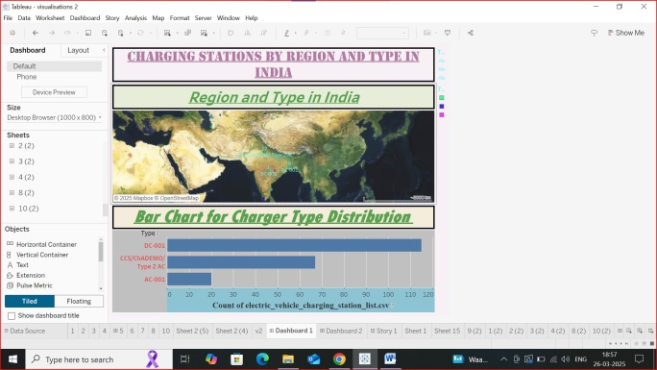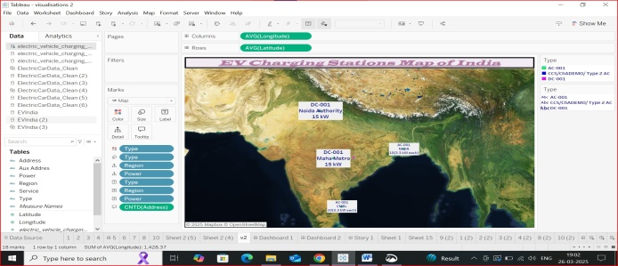

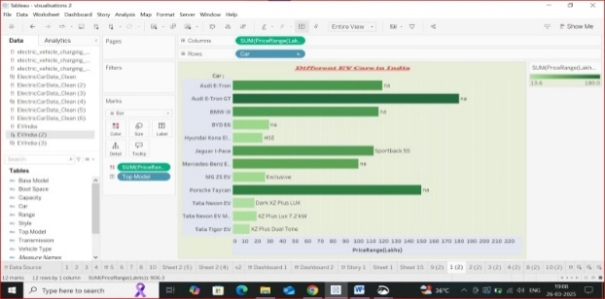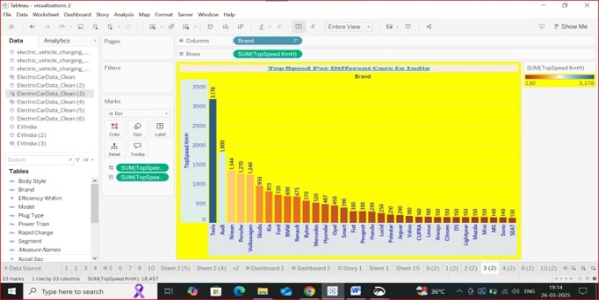

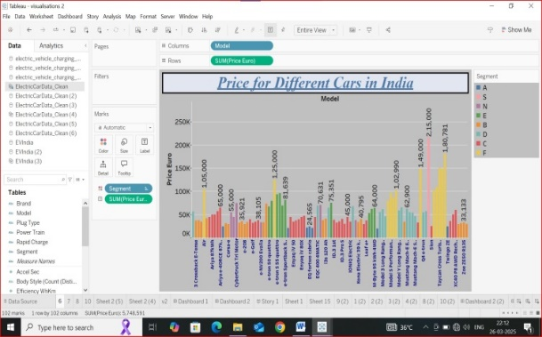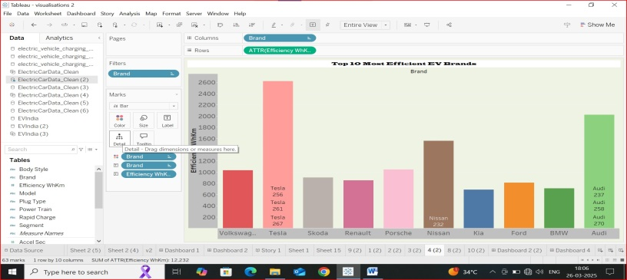

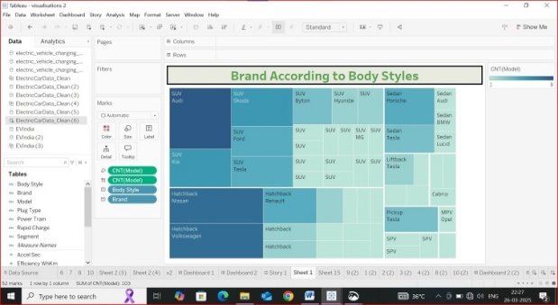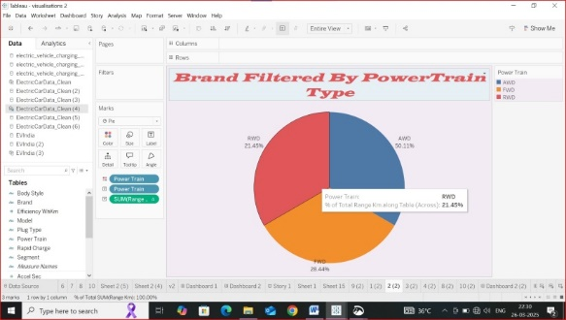

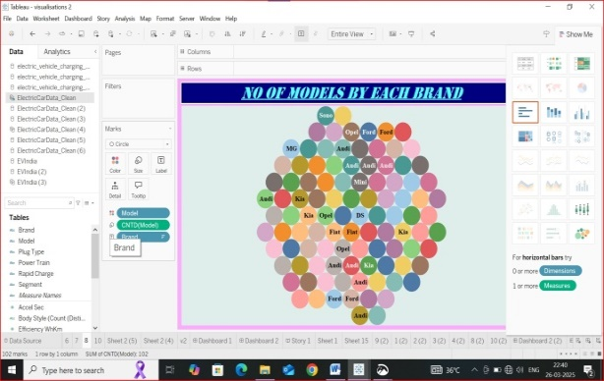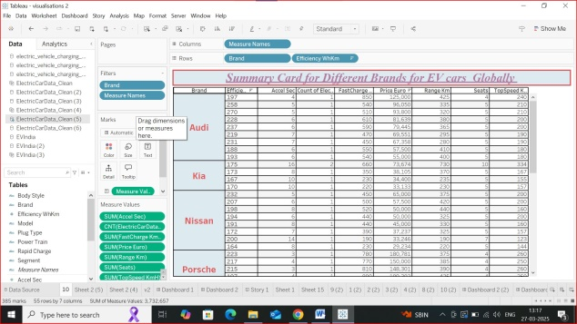

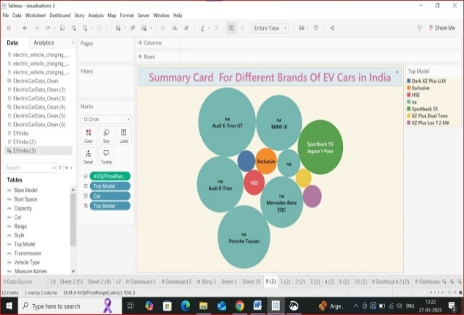

**Names of Visualizations:**

1. charging stations by region

2.EV charging Stations map of India

3.Different EV cars in India

4.Top speed for Different Cars in India

5. Price for different cars in India

6.Top 10 most Efficient EV Brands

7.Brand According to body styles

8.Brand Filtered by powertrain Type

9.No. of Brands By Each Brand

10.Summary cards for Different Brands for EV Cars Globally

11. Summary cards for Different Brands in India

1. **Dashboard**
   1. **Dashboard Design File**

<https://public.tableau.com/views/Dashboard_17429723074010/Dashboard2?:language=en-GB&:sid=&:redirect=auth&:display_count=n&:origin=viz_share_link>

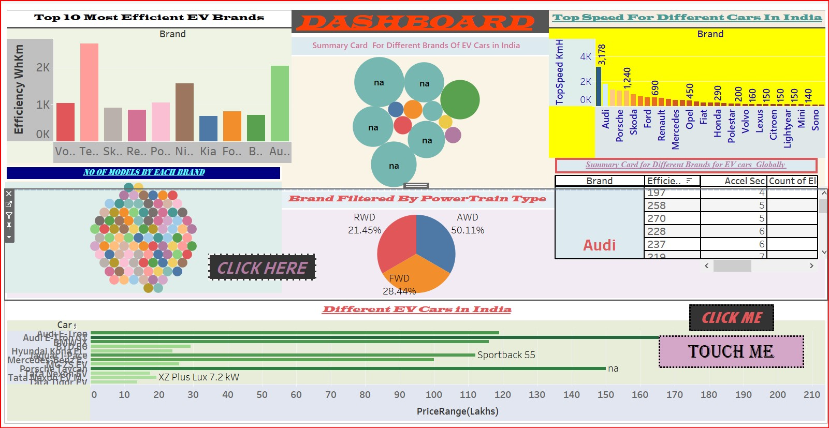

1. **Report**
   1. **Story Design File**

**<https://public.tableau.com/shared/Q6QH4BD37?:display_count=n&:origin=viz_share_link>**

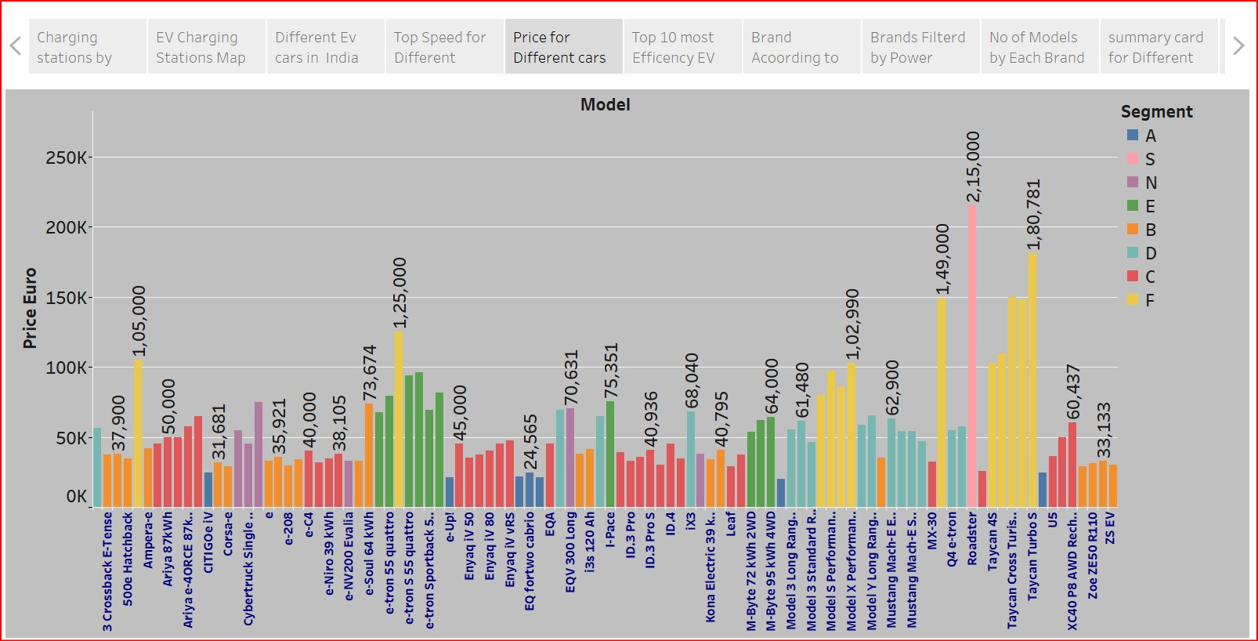

1. **Performance Testing**
   1. **Utilization of Data filters**

Purpose: Ensure optimal filtering to improve dashboard performance.

Example Filters:

Date Range: Show charge sessions for specific time periods.

Vehicle Type: Filter data by EV make/model.

Location: Display data for specific charging stations or cities.

Charge Level: Filter by slow, fast, or supercharger sessions.

* 1. **No of Calculation Field**

Purpose: Reduce complexity and improve dashboard speed.

Examples of Calculated Fields:

Charge Duration (hrs) = DATEDIFF('hour', [Start Time], [End Time])

Efficiency (Miles per kWh) = [Range] / [Battery Capacity]

Average Charge Cost = [Total Cost] / [kWh Consumed]

8**. No of Visualization**

1. charging stations by region

2.EV charging Stations map of India

3.Different EV cars in India

4.Top speed for Different Cars in India

5. Price for different cars in India

6.Top 10 most Efficient EV Brands

7.Brand According to body styles

8.Brand Filtered by powertrain Type

9.No. of Brands By Each Brand

10.Summary cards for Different Brands for EV Cars Globally

11. Summary cards for Different Brands in Indi

1. **Conclusion/Observation**

The Electric Vehicle Charge and Range Analysis project using Tableau provides valuable insights into charging station availability, battery range, energy consumption, and driving patterns. By leveraging interactive dashboards, geospatial analysis, and predictive modeling, this project enhances decision-making for EV users, policymakers, and energy providers.

With real-time data integration, machine learning forecasts, and smart routing visualizations, the project helps optimize EV trip planning, infrastructure development, and sustainable energy usage. Future enhancements, such as real-time charging station updates and grid impact analysis, can further improve EV adoption and efficiency. Ultimately, this project contributes to better EV infrastructure planning, improved user experience, and a more sustainable transportation ecosystem, supporting the global shift towards cleaner mobility solutions

1. **Future Scope**

* **Real-Time Data Dashboards**

Integrate live charging station data, traffic conditions, and weather updates using Tableau’s real-time data connectors.

Create interactive dashboards that dynamically update charging station availability and estimated wait times

* **predictive Analytics & AI Integration**

Use Tableau’s forecasting models to predict battery consumption, charging demand, and vehicle range based on historical data.

Implement machine learning models externally (e.g., Python, R) and integrate their outputs into Tableau visualizations.

* **Mobile & Web Dashboard Deployment**

Deploy interactive Tableau dashboards accessible via mobile devices for real-time decision-making.

Enable custom user filters to provide personalized insights based on vehicle type and driving patterns.

1. **Appendix**
   1. Source Code(if any)
   2. GitHub & Project Demo Link